Student Participation Analysis & Predictive Insights
Program Insights & Recommendation Report

AI-Powered Data Insights Internship
Excelerate
Team 4

Executive Summary
This report presents the final findings of the Student Participation Analysis project completed as part of the AI-Powered Data Insights Internship with Excelerate. The project combined data preparation, exploratory data analysis, predictive modelling, business recommendations, and a success measurement framework to better understand learner participation and support future programme planning.
The dataset contains 8,558 learner participation records and 16 original attributes, including demographic, academic, geographic, opportunity, registration, and participation information. Exploratory analysis showed that Internships were the most common opportunity category, representing 5,421 records, or 63.34% of total participation, while Courses represented 23.80%. Internship opportunities also showed a high rejection rate, with 65.84% of applications rejected and 21.49% progressing to Team Allocated.
Participation patterns also varied over time. Internship activity increased strongly between August and January, with particularly high registration activity around January and February 2024. Geographic analysis showed that learners came from 70 countries; however, participation was highly concentrated in the United States, India, and Nigeria, which together represented 88.48% of all participation.
Four machine learning models were evaluated: Logistic Regression, Decision Tree, Random Forest, and XGBoost. Random Forest achieved the strongest predictive performance, with 86.04% accuracy, 92.35% precision, 77.06% recall, an F1-score of 84.01%, and a ROC-AUC score of 0.9320. Feature importance analysis identified Opportunity Category and Opportunity Duration as the strongest predictors of learner participation, followed by variables such as Signup Month, Institution Name, and Current/Intended Major.
Based on these findings, the project recommends expanding high-demand opportunities, improving learner-opportunity matching, strengthening learner engagement and retention, using historical participation patterns for programme planning, expanding outreach to underrepresented regions, and using predictive analytics to support decision-making.
A KPI and success measurement framework is also proposed to help Excelerate monitor participation, programme outcomes, geographic diversity, and predictive model performance over time. This framework is designed to support continuous improvement and ensure that future decisions remain evidence-based and measurable.
Overall, the project demonstrates how historical learner data, exploratory analysis, and machine learning can be combined to generate practical insights that support learner engagement, programme design, resource allocation, and future planning.

1. Introduction
Learner participation is an important indicator of the effectiveness and accessibility of educational and professional development opportunities. Understanding the factors that influence participation can help organizations improve programme planning, allocate resources more effectively, strengthen learner engagement, and support better decision-making.
This project analyses the Rochester Institute of Technology Student Participation Dataset as part of the AI-Powered Data Insights Internship with Excelerate. The dataset contains 8,558 learner participation records and 16 original features. These records include information about learner demographics, academic background, geographic location, opportunity characteristics, registration dates, and participation outcomes. Opportunities are grouped into five main categories: Internship, Course, Event, Competition, and Engagement.
The project was completed in several connected stages. The first stage focused on understanding the dataset, identifying data quality issues, and preparing the data for analysis. The second stage used exploratory data analysis and feature engineering to examine learner participation across opportunity categories, demographics, geography, institutions, academic majors, engagement outcomes, and registration patterns. Temporal features were also created to capture changes in learner activity over time.
The third stage focused on predictive modelling. Learner participation was treated as a binary classification problem, and four machine learning algorithms were developed and evaluated: Logistic Regression, Decision Tree, Random Forest, and XGBoost. Model performance was assessed using Accuracy, Precision, Recall, F1-score, and ROC-AUC to identify the most suitable model for participation prediction.
The final stage brings together the findings from the previous analyses and translates them into practical recommendations for future programme planning. The overall objective is to move from data understanding and descriptive analysis to predictive decision support and measurable business actions. The findings can support improvements in programme design, learner engagement, opportunity allocation, outreach strategies, and resource planning.

2. Summary of Findings
The analysis conducted across Weeks 1–3 identified several important patterns related to learner participation, opportunity demand, learner characteristics, geographic distribution, registration behaviour, and predictive performance.

2.1 Opportunity Participation
Internships were the dominant opportunity category, accounting for 5,421 records, or 63.34% of total participation. Courses represented 2,037 records, or 23.80%. Together, Internships and Courses accounted for more than 87% of all learner participation, showing that learners were mainly interested in career-focused and skill-development opportunities.
Internship opportunities also showed a different participation outcome pattern compared with other categories. Approximately 65.84% of internship applications were rejected, while only 21.49% progressed to Team Allocated status. This suggests that internships attracted strong learner demand but were also more competitive than other opportunity types.

2.2 Temporal Participation Patterns
Learner registrations changed over time rather than remaining constant. Internship participation increased substantially between August and January, with particularly high levels of activity around January and February 2024. Courses showed more stable participation throughout the year.
These patterns show that learner registration activity varied across the study period. Historical periods of higher activity can be used descriptively to support the timing of future programme launches, promotional campaigns, and resource planning.

2.3 Learner Profile
The average learner age was approximately 26.8 years, with most learners falling within the 18–34 age range. This indicates that the programme mainly attracted university students, recent graduates, and early-career professionals.
Technology-related academic disciplines were strongly represented, including Information Systems, Computer Science, Health Data Science, and Cyber Security. These patterns suggest strong interest in technology-focused educational and career opportunities among the learner population.

2.4 Geographic Participation
The dataset included learners from 70 countries, demonstrating broad international reach. However, participation was highly concentrated in a small number of countries. The United States contributed 3,976 records, India 2,836, and Nigeria 760. Together, these three countries represented 88.48% of total participation.
This geographic concentration suggests an opportunity to maintain engagement in existing high-participation markets while also developing targeted outreach strategies for underrepresented regions.

2.5 Predictive Model Performance
Four supervised machine learning algorithms were evaluated for learner participation prediction: Logistic Regression, Decision Tree, Random Forest, and XGBoost.
Random Forest achieved the strongest reported predictive performance, with:
- Accuracy: 86.04%
- Precision: 92.35%
- Recall: 77.06%
- F1-Score: 84.01%
- ROC-AUC: 0.9320
Logistic Regression also provided a strong interpretable baseline, achieving 83.12% accuracy and a ROC-AUC score of 0.8624.
These results support the use of Random Forest as the preferred predictive model for identifying participation patterns and supporting future programme planning.

2.6 Key Drivers of Participation
Random Forest feature importance analysis identified Opportunity Category and Opportunity Duration as the strongest predictors of learner participation. Other important variables included Signup Month, Current/Intended Major, Institution Name, Age, and registration timing variables.
The results suggest that programme characteristics and registration behaviour have greater predictive importance in the model than demographic variables alone. This provides practical evidence for focusing programme improvements on opportunity design, duration, timing, and learner-opportunity alignment.

2.7 Overall Insight
Overall, the findings show that learner participation is influenced by a combination of opportunity characteristics, temporal participation patterns, academic background, geographic location, and registration behaviour. The combination of exploratory analysis and predictive modelling provides a strong foundation for developing targeted recommendations that can improve learner engagement, programme planning, resource allocation, and future decision-making.

3. Visual Insights & Supporting Materials
This section presents the key visual insights generated from the exploratory and predictive analyses conducted throughout the project. The selected visualizations highlight learner demand, participation outcomes, geographic concentration, temporal registration patterns, predictive model performance, and the main factors influencing learner participation. Together, these visuals provide evidence supporting the recommendations presented later in this report.

3.1 Opportunity Category Distribution
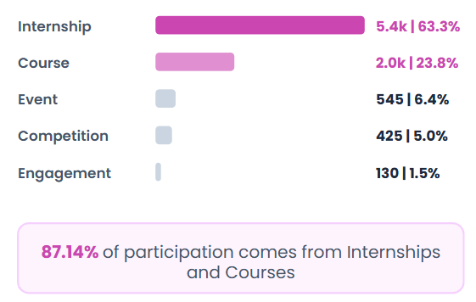
Figure 1. Opportunity Category Distribution
Internships represented the largest share of learner participation, accounting for 63.34% of all records, followed by Courses at 23.80%. Events, Competitions, and Engagement opportunities represented substantially smaller proportions. Overall, Internships and Courses accounted for 87.14% of participation, demonstrating strong learner interest in career-focused and skill-development opportunities.

3.2 Participation Outcomes by Opportunity Category
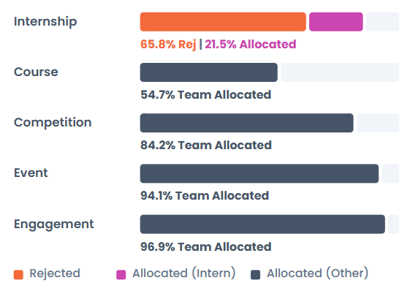
Figure 2. Participation Outcomes by Opportunity Category
Participation outcomes varied considerably across opportunity types. Internship opportunities recorded the highest rejection rate, with approximately 65.84% of applications rejected and 21.49% progressing to Team Allocated. In comparison, Courses, Competitions, Events, and Engagement opportunities showed substantially higher Team Allocation rates.
This contrast indicates that internships attract strong learner demand while also operating within a more competitive selection environment. The finding supports reviewing internship capacity, learner-opportunity matching, and application guidance.

3.3 Temporal Participation Trends
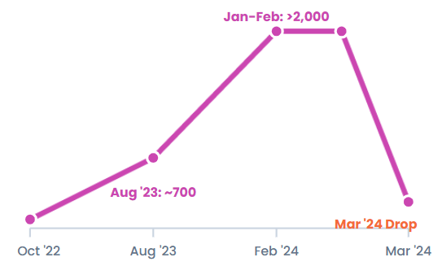
Figure 3. Monthly Learner Participation Trend
Learner registration activity showed clear variation over time. Internship participation increased substantially between August and January, with particularly high activity around January and February 2024, while Course participation remained comparatively stable.
These patterns suggest that programme launches, outreach campaigns, and resource allocation can be better aligned with periods of historically high learner activity.

3.4 Monthly Participation Pattern
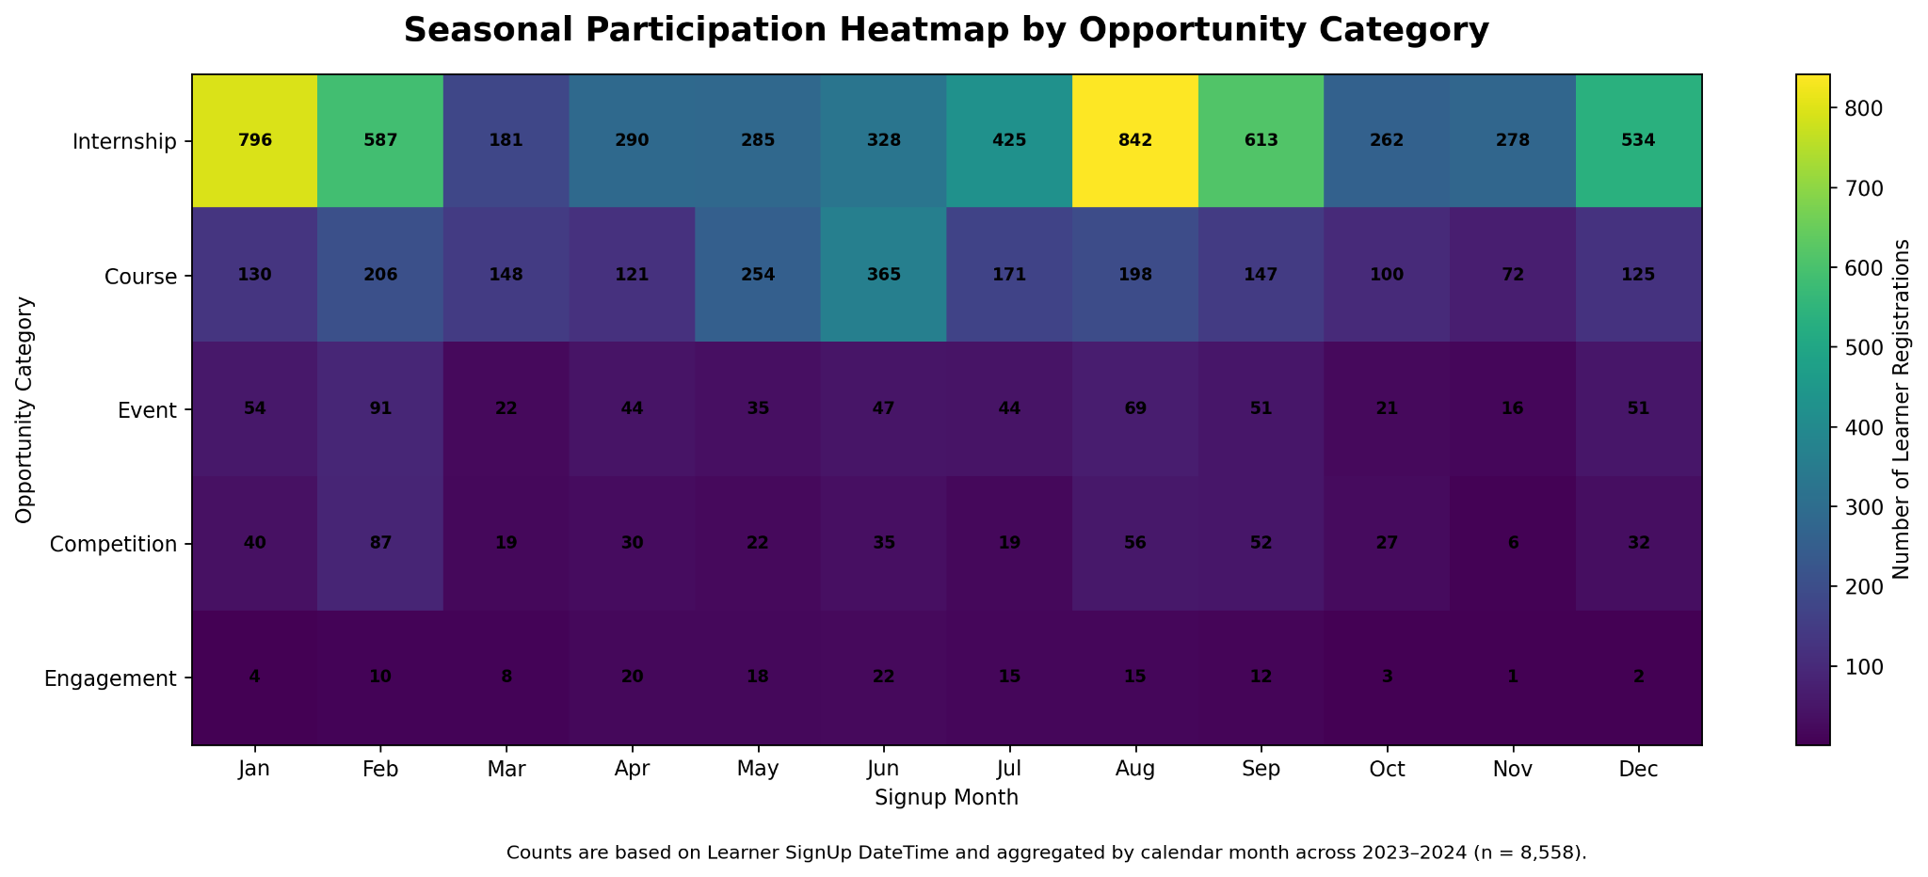
Figure 4. Monthly Participation Heatmap by Opportunity Category
The heatmap shows monthly learner registration patterns across the five opportunity categories, aggregated across 2023–2024. Internship participation was highest in August and January, with additional high activity in September, February, and December. Course participation was more evenly distributed, with its highest activity in June. Event, Competition, and Engagement opportunities recorded lower participation volumes overall. These results highlight differences in monthly registration activity and can support the planning of programme launches, outreach campaigns, and resource allocation.

3.5 Geographic Participation
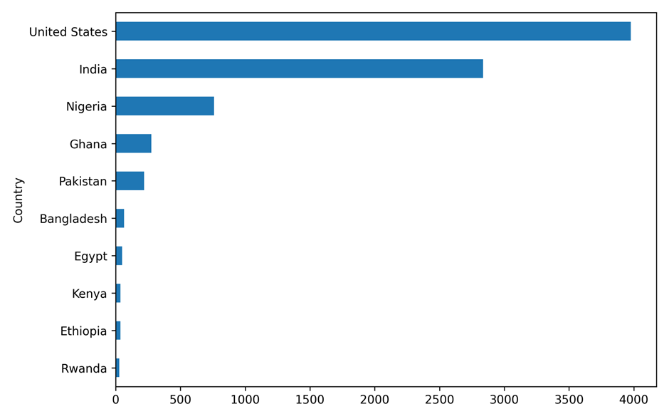
Figure 5. Geographic Distribution of Learner Participation
The learner population represented 70 countries, demonstrating international reach. However, participation was highly concentrated in the United States, India, and Nigeria, which together accounted for 88.48% of total participation.
This concentration highlights an opportunity to maintain engagement in established markets while expanding targeted outreach to currently underrepresented countries and regions.

3.6 Predictive Model Performance
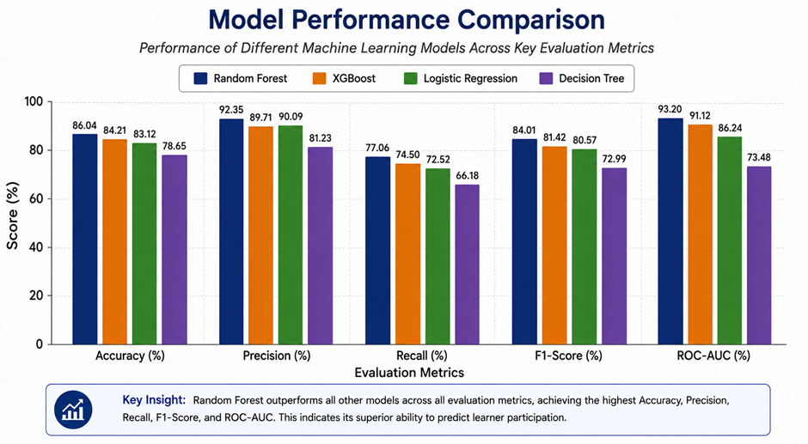
Figure 6. Predictive Model Performance
Random Forest achieved the strongest reported predictive performance, with an accuracy of 86.04%, precision of 92.35%, recall of 77.06%, an F1-score of 84.01%, and a ROC-AUC score of 0.9320.
The results indicate that Random Forest provides a strong foundation for learner participation prediction and can support future data-driven programme planning when combined with continued monitoring and human judgement.

3.7 Key Drivers of Learner Participation
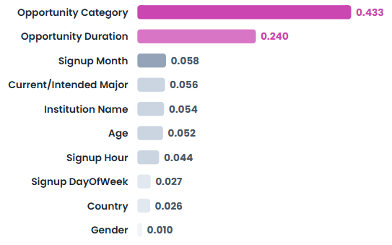
Figure 7. Random Forest Feature Importance
Feature importance analysis identified Opportunity Category (0.433) and Opportunity Duration (0.240) as the two strongest predictive factors. Their feature importance scores sum to 0.673 within the Random Forest model. This value represents their relative contribution to the model’s predictions and should not be interpreted as a causal effect or as explaining 67.3% of learner participation. Signup Month, Current/Intended Major, Institution Name, Age, Signup Hour, Signup Day of Week, Country, and Gender also contributed to the model.
The results indicate that programme characteristics, particularly opportunity category and duration, received greater predictive importance in the model than demographic variables. This supports prioritizing opportunity design and scheduling when developing participation strategies.

3.8 Random Forest Classification Results
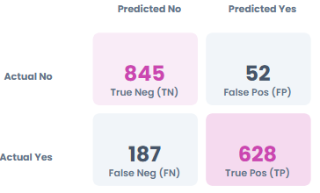
Figure 8. Random Forest Confusion Matrix
The Random Forest model correctly classified 1,473 of the 1,712 observations in the test set. The confusion matrix contained 845 true negatives, 628 true positives, 52 false positives, and 187 false negatives.
These results demonstrate strong overall classification performance. The ROC-AUC score of 0.932 further indicates that the model has a strong ability to distinguish between learners classified as participants and non-participants.

3.9 Proposed Success Measurement Dashboard
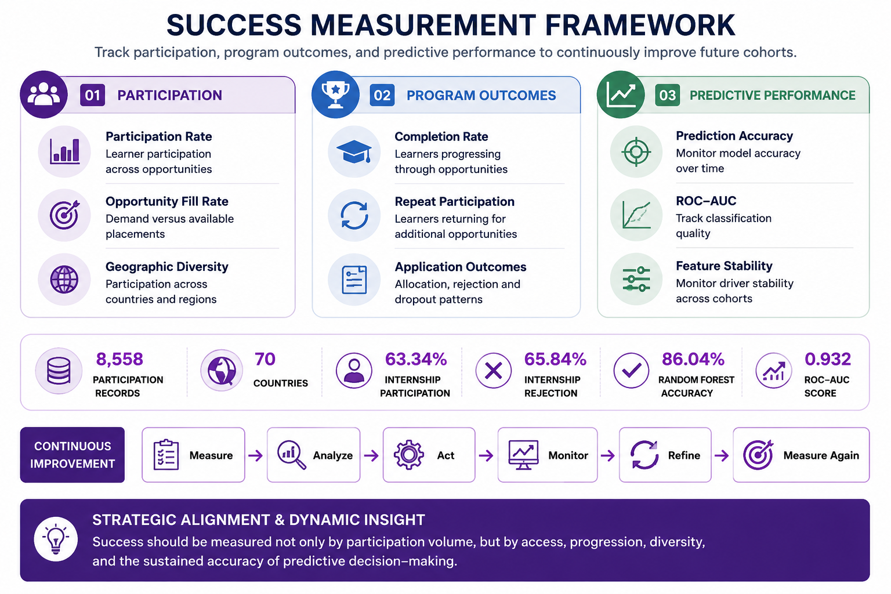
Figure 9. Proposed Success Measurement Framework
The proposed measurement framework organizes future monitoring into three areas: participation, programme outcomes, and predictive performance. Key measures include Participation Rate, Opportunity Fill Rate, Geographic Diversity, Completion Rate, Repeat Participation, Prediction Accuracy, ROC-AUC, and Feature Stability.
The framework is designed to support continuous improvement by allowing programme teams to measure results, analyze changes, refine strategies, and monitor predictive performance across future cohorts.

3.10 Visual Insights Summary
Overall, the visual evidence shows that learner participation is highly concentrated in internship opportunities and a small number of geographic markets, while registration activity also follows clear temporal patterns. Predictive modelling further indicates that opportunity characteristics, particularly category and duration, are important drivers of participation. These findings provide the analytical foundation for the strategic recommendations and implementation priorities presented in the following sections.

4. Recommendations & Business Impact
Based on the exploratory analysis and predictive modelling results, several evidence-based recommendations are proposed to improve learner participation, strengthen programme effectiveness, and support more informed decision-making.

4.1 Expand and Optimize High-Demand Opportunities
Internships accounted for 63.34% of total participation and represented the strongest area of learner demand. However, internship applications also showed a 65.84% rejection rate and only 21.49% progressed to Team Allocated.
Excelerate should therefore review the availability, design, and capacity of high-demand internship opportunities. Where feasible, additional internship opportunities or similar career-focused programmes could be introduced to better respond to learner demand. Eligibility requirements and opportunity descriptions should also be reviewed to ensure that learners understand programme expectations before applying.
This approach can improve opportunity alignment, application quality, and the overall use of available programme capacity.

4.2 Use Participation Trends for Programme Planning
Learner activity showed clear temporal patterns, particularly for internships, with participation increasing substantially between August and January and reaching particularly high levels around January and February.
Programme launches, communication campaigns, and resource planning should therefore be aligned with historically active participation periods. Lower-activity periods can also be used for preparation, learner awareness campaigns, and early promotion of upcoming opportunities.
Using historical participation patterns in programme scheduling can support more efficient use of resources and improve the timing of learner outreach.

4.3 Improve Learner-Opportunity Matching and Application Guidance
The high level of internship rejection suggests that learner demand does not always translate into successful progression through the application process.
Clearer eligibility requirements, more detailed opportunity descriptions, and improved application guidance can help learners identify opportunities that better match their academic background, interests, and experience. These measures may improve application quality and reduce avoidable mismatches between learners and available opportunities.
Clearer eligibility requirements and improved learner-opportunity matching can strengthen application management by helping learners apply for opportunities that better align with their qualifications and interests.

4.4 Strengthen Learner Engagement and Retention
Learner support should extend beyond initial registration and application. Structured onboarding, reminders, follow-up communication, and clear programme expectations can help learners remain engaged throughout the participation process.
Improved learner support can reduce disengagement and strengthen progression and retention, particularly for opportunities that involve multiple stages or longer durations.

4.5 Expand Geographic Outreach
Although learners represented 70 countries, 88.48% of participation came from the United States, India, and Nigeria. This indicates strong reach in several markets but also significant geographic concentration.
Excelerate should maintain engagement in its established markets while developing targeted outreach strategies for underrepresented regions. Regional campaigns, partnerships, and tailored communication could help broaden participation and reduce dependence on a small number of markets.
Targeted regional strategies are expected to support geographic growth beyond current high-participation markets.

4.6 Use Predictive Analytics as Decision Support
Random Forest achieved the strongest predictive performance among the evaluated models. The model can therefore provide an additional source of evidence for future programme planning, learner engagement, and resource allocation.
Predictive outputs should be used alongside historical participation trends, programme knowledge, and human judgement rather than as a replacement for decision-makers. Model performance should also be monitored as new data becomes available to ensure that its predictive value remains reliable over time.

4.7 Business Impact
Taken together, the recommendations can support improvement across several areas of programme management.
Area | Potential Business Impact
Learner Engagement | More relevant opportunities and targeted communication can encourage stronger participation.
Programme Planning | Historical participation patterns can improve the timing of programme launches and campaigns.
Application Management | Clearer requirements and better opportunity matching can improve application quality.
Learner Retention | Improved onboarding and follow-up can reduce disengagement and support learner progression.
Resource Allocation | Participation trends and predictive insights can support more effective allocation of programme resources.
Geographic Growth | Targeted regional outreach can expand participation beyond existing high-participation markets.
Decision-Making | Predictive analytics can provide additional evidence for programme planning and intervention decisions.
These business impact areas summarize the expected organizational value of the proposed recommendations.

4.8 Overall Business Impact
The overall value of these recommendations is their ability to help Excelerate make better-informed decisions about learners, opportunities, timing, and resources. Rather than relying only on historical participation totals, the organization can combine descriptive insights with predictive evidence to understand where demand exists, when learners are most active, and which areas require additional support.
This approach can help move programme management from reactive reporting toward more proactive, evidence-based planning.

5. Implementation Roadmap & Expected Benefits
A phased implementation approach is recommended to ensure that the proposed strategies can be introduced gradually, evaluated using measurable outcomes, and refined as additional data becomes available.

5.1 Phase 1: Establish the Foundation — 0–3 Months
During the first three months, the focus should be on establishing a clear baseline and preparing the organization for future improvements.
Key activities should include:
- Establish baseline participation and application metrics.
- Review internship opportunities and other high-demand opportunity categories.
- Review eligibility requirements and opportunity descriptions.
- Identify periods of high and low learner participation.
- Establish a regular reporting process for key participation indicators.
The expected outcome of this phase is a clearer understanding of current learner demand, participation patterns, and programme performance, providing a reliable foundation for measuring future improvement.

5.2 Phase 2: Implement Targeted Strategies — 3–6 Months
The second phase should focus on applying the insights identified during the analysis to learner engagement, communication, and programme planning.
Key activities should include:
- Increase promotion of high-demand and career-focused opportunities.
- Schedule engagement campaigns around historically active participation periods.
- Strengthen learner onboarding and follow-up communication.
- Improve guidance on eligibility and application requirements.
- Develop targeted outreach strategies for selected underrepresented regions and learner groups.
The expected outcome is improved learner engagement, stronger application quality, and better progression through the participation process.

5.3 Phase 3: Introduce Predictive Decision Support — 6–12 Months
Once baseline monitoring and targeted engagement strategies have been established, predictive analytics can be introduced more formally into programme planning.
Key activities should include:
- Integrate the validated Random Forest model into analytical reporting or programme monitoring.
- Monitor model performance as new learner data becomes available.
- Review important predictive features regularly to identify changes in participation drivers.
- Use predictive insights alongside programme knowledge and human judgement when planning interventions.
- Compare participation outcomes before and after implementing the recommended strategies.
The expected outcome is a more proactive approach to programme management supported by both historical evidence and predictive insights.

5.4 Expected Benefits
If implemented effectively, the proposed recommendations are expected to provide several organizational benefits.
Increased Learner Participation
Better alignment between available opportunities and learner interests can help attract learners to programmes that are more relevant to their goals.
Improved Application Quality
Clearer eligibility requirements, opportunity descriptions, and application guidance can help learners make more informed application decisions.
Improved Learner Retention
Stronger onboarding, reminders, and follow-up communication can support learners throughout the participation process and reduce disengagement.
More Effective Programme Planning
Understanding when and where participation occurs can help improve programme scheduling, campaign timing, and resource allocation.
Better Opportunity Alignment
Insights into learner preferences and participation drivers can support the design of programmes that better reflect learner demand.
More Informed Decision-Making
Predictive analytics can provide an additional layer of evidence to support programme planning and learner engagement decisions.
Continuous Improvement
Regular monitoring of programme outcomes will allow the organization to evaluate the effectiveness of interventions and refine its strategies over time.

5.5 Expected Outcomes After 12 Months
Because post-implementation performance data is not yet available, specific improvement percentages should not be presented as confirmed outcomes. Instead, the following represent realistic directional goals for the first 12 months:
- More consistent learner participation across programme periods.
- Increased engagement with high-demand internship opportunities.
- Better alignment between learner interests and available opportunities.
- Improved application quality.
- Stronger learner progression and retention.
- More targeted engagement in underrepresented regions.
- More efficient use of programme and outreach resources.
- More regular use of data in programme planning and decision-making.
- A validated predictive framework that can support future learner engagement strategies.

5.6 Roadmap Summary
The proposed roadmap provides a gradual pathway from establishing performance baselines to implementing targeted engagement strategies and finally integrating predictive analytics into programme planning. This phased approach allows results to be monitored before wider implementation and supports continuous adjustment based on evidence rather than assumptions.

6. KPI Framework & Success Measurement Plan
The proposed KPI framework translates the project findings and recommendations into measurable indicators that can be monitored over time. These business KPIs are separate from the machine learning evaluation metrics used during model development. Metrics such as Accuracy and ROC-AUC evaluate model performance, while the KPIs below are intended to measure whether programme strategies are producing meaningful organizational outcomes.

6.1 Proposed KPI Framework
KPI | What It Measures | Proposed Target | Review Frequency
Participation Rate | Percentage of registered learners who move into active participation. | Baseline + incremental growth each cycle | Monthly
Opportunity Fill Rate | Extent to which available opportunity capacity is filled by participants. | ≥ 90% per opportunity | Per opportunity cycle
Programme Completion Rate | Percentage of learners who successfully progress through and complete an opportunity after starting. | Incremental improvement from baseline | Quarterly
Geographic Diversity Index | Distribution of participation across countries and regions. | Reduce concentration in the current top three countries | Quarterly
Underrepresented Region Participation | Participation from regions currently contributing a relatively small share of learners. | Measurable increase over 2–3 review cycles | Quarterly
Repeat Participation Rate | Percentage of learners who participate in more than one opportunity. | Establish baseline, then improve over time | Quarterly
Outreach Conversion Rate | Percentage of outreach contacts that result in applications. | Establish baseline, then improve over time | Monthly
Prediction Adoption Rate | Percentage of future programme planning decisions in which predictive insights are consulted. | ≥ 70% within two quarters | Quarterly
Model Performance Monitoring | Ongoing classification performance of the Random Forest model on newly labelled data. | Maintain stable performance relative to the validated baseline and investigate material declines. | Quarterly or after model refresh
The KPI definitions cover participation, programme capacity, completion, geographic diversity, repeat engagement, outreach effectiveness, and future use of predictive analytics.
Note: The targets presented in this framework are proposed initial benchmarks rather than confirmed performance commitments. They should be reviewed and refined once sufficient post-implementation baseline data becomes available.

6.2 Participation and Programme Performance
Participation Rate and Opportunity Fill Rate provide direct measures of whether learner interest is translating into active programme participation and whether available programme capacity is being used effectively.
Programme Completion Rate adds an important outcome measure by focusing on learner progression after participation begins rather than measuring registration alone. Repeat Participation Rate can also provide an indication of longer-term learner engagement across multiple opportunities.
Together, these indicators can help programme teams distinguish between attracting applications, converting learners into active participants, and maintaining engagement throughout the programme lifecycle.

6.3 Geographic and Outreach Performance
Geographic participation should be monitored to determine whether outreach strategies are helping to reduce the current concentration of participation in the United States, India, and Nigeria.
The Geographic Diversity Index can track changes in concentration over time, while Underrepresented Region Participation can measure whether participation is expanding into markets with lower historical representation. Outreach Conversion Rate can then help determine whether communication and regional outreach activities are translating into actual learner applications.
This approach allows geographic expansion to be evaluated through measurable outcomes rather than outreach activity alone.

6.4 Predictive Model Monitoring
The predictive model should continue to be evaluated after implementation rather than relying only on its initial development performance.
The Random Forest model should be monitored on newly labelled data using the same classification metrics applied during model validation: Accuracy, Precision, Recall, F1-score, and ROC-AUC. These metrics should be compared with the validated baseline during scheduled reviews and after each model refresh. Prediction Adoption Rate can also be used to assess whether predictive insights are being incorporated into programme planning. If opportunity-level numerical forecasts are developed in the future, forecasting-specific metrics such as MAPE could then be introduced separately.

6.5 Success Measurement Plan
The success measurement plan connects the proposed recommendations with measurable indicators and regular review periods. The objective is to create a continuous feedback process in which programme teams can measure performance, identify changes, take action, and refine strategies based on evidence.
For example, geographic outreach strategies can be evaluated using Geographic Diversity and Underrepresented Region Participation, learner support strategies can be evaluated through Completion and Repeat Participation rates, and predictive decision support can be evaluated through model adoption and ongoing classification performance.
Regular KPI review helps ensure that recommendations do not remain one-time findings but instead become part of an ongoing process of programme evaluation and improvement.

6.6 Continuous Improvement
The measurement framework should operate as a repeating cycle:
Measure → Analyze → Act → Monitor → Refine → Measure Again
As new learner and programme data becomes available, results should be compared with established baselines and previous review periods. Strategies that produce positive outcomes can be maintained or expanded, while areas that do not improve can be investigated and adjusted.
This continuous monitoring approach helps ensure that participation strategies, programme decisions, and predictive tools remain relevant as learner behaviour and programme conditions change over time.

7. AI Usage & Validation
AI assistance was used throughout the project to support data understanding, analytical interpretation, code review, visualization development, machine learning evaluation, and final documentation. AI was used as a supporting tool rather than as a replacement for the team’s analytical judgement or decision-making.
The analytical work was carried out using Google Colab and the standard Python data science environment, including tools such as Pandas, NumPy, Matplotlib, and Scikit-learn. AI-generated suggestions, explanations, and code recommendations were reviewed against executed analytical outputs before being incorporated into the project deliverables.

7.1 AI-Assisted Project Activities
During the data understanding stage, AI assistance was used to help interpret the dataset structure, identify potential data quality concerns, explain preprocessing approaches, and support the preparation of descriptive summaries.
During exploratory analysis and feature engineering, AI supported the development and interpretation of demographic, geographic, temporal, participation, and engagement analyses. It also assisted with visualization development and the communication of analytical findings.
During predictive modelling, AI was used to review machine learning workflows, explain modelling approaches, support evaluation and comparison of algorithms, and assist with interpretation of model performance and feature importance. Model training, metrics, and visual outputs were generated and verified through executed code in Google Colab.
During final documentation, AI supported the organization and refinement of findings, recommendations, KPI documentation, validation procedures, and the communication of technical results for a broader audience. Final content was reviewed against the validated analytical findings before inclusion in the report.

7.2 Representative Prompt Documentation
The following table summarizes representative types of AI prompts used during the project rather than reproducing every individual interaction.
Project Stage | Purpose of AI Assistance | Representative Prompt Summary | Validation Method
Data Understanding | Understand dataset structure and data quality | Explain the dataset structure, identify possible data quality issues, and recommend appropriate preprocessing steps. | Compared suggestions with dataset inspection and executed data-quality checks in Google Colab.
Exploratory Analysis | Support EDA, feature engineering, and visualization | Recommend useful analyses and features for examining demographic, geographic, temporal, and participation patterns. | Findings and calculations were checked against the processed dataset and generated visualizations.
Predictive Modelling | Review modelling workflow and interpret results | Review the machine learning workflow, compare models, explain evaluation metrics, and interpret feature importance and classification results. | Models and evaluation metrics were generated through executed code and compared before final model selection.
Final Reporting | Improve communication and documentation | Organize validated findings into clear recommendations, KPI frameworks, and report sections for technical and non-technical audiences. | Final statements, figures, and numerical results were cross-checked against validated project outputs.
This approach provides transparency about how AI contributed to the project while ensuring that reported findings remained supported by actual analytical outputs.

7.3 Benefits and Limitations of AI Assistance
AI assistance helped accelerate exploratory work, explain statistical and machine learning concepts, review analytical approaches, and improve the clarity and structure of project documentation.
However, AI-generated explanations and code cannot be assumed to be correct automatically. Suggested code may require modification when executed against the actual dataset, and interpretations must be checked against real results. For this reason, analytical conclusions were based on executed outputs rather than AI-generated statements alone.

7.4 Human Oversight and Responsible Use
Human oversight remained essential throughout the project. Decisions relating to data preparation, feature engineering, target-variable definition, model selection, interpretation, and final recommendations remained the responsibility of the project team.
AI-generated suggestions were treated as supporting input and were reviewed before use. Particular attention was also given to responsible handling of learner and demographic information and to avoiding over-reliance on predictive outputs when making programme decisions.

7.5 Validation Process
To ensure the reliability of the final findings, analytical results and AI-assisted outputs were validated before inclusion in the final deliverables. The validation process included:
- Data quality checks: reviewing missing values, duplicate records, inconsistent formats, and other potential quality issues.
- Preprocessing verification: confirming that cleaning, feature engineering, and transformations were applied correctly.
- Analytical cross-checking: comparing descriptive statistics, participation patterns, geographic results, and other findings with the processed dataset.
- Feature engineering validation: checking that engineered variables represented their intended analytical meaning.
- Model performance validation: evaluating models using Accuracy, Precision, Recall, F1-score, ROC-AUC, and confusion matrices.
- Model comparison: comparing Logistic Regression, Decision Tree, Random Forest, and XGBoost using consistent evaluation criteria.
- Visualization review: checking that charts and tables accurately represented the validated analytical outputs.
- Team quality assurance: reviewing interpretations, terminology, figures, and reported results for consistency across the final deliverables.
This validation process helped ensure that the final recommendations and conclusions were based on traceable analytical evidence rather than unverified AI output.

8. Reflection & Internship Feedback
The internship provided practical experience in applying data analysis, machine learning, visualization, and business communication skills to a real learner participation dataset. The project demonstrated how technical analysis can be connected to practical recommendations and programme decision-making.

8.1 Personal Learning
Through the project, I strengthened my practical skills in Python, exploratory data analysis, data visualization, machine learning, and model evaluation. I also gained greater experience in interpreting analytical results and presenting them in a way that can be understood by both technical and non-technical audiences.
My contributions included demographic analysis, Random Forest model development and evaluation, model visualizations, and final report quality assurance. Working on these areas helped me better understand the complete data science workflow, from understanding and preparing data to evaluating models and communicating the final insights.
The Random Forest modelling stage was particularly valuable because it provided practical experience with model tuning and evaluation using metrics such as Accuracy, Precision, Recall, F1-score, and ROC-AUC. It also demonstrated the importance of reviewing confusion matrices and feature importance when interpreting predictive models.

8.2 Team Collaboration
The project also highlighted the importance of collaboration in data analytics. Different components of the project were completed by team members and later combined into a single final deliverable.
This required communication, coordination, consistency checks, and review of analytical results across multiple project stages. The experience reinforced the importance of ensuring that figures, terminology, model results, recommendations, and visualizations remain consistent when work from several contributors is combined.

8.3 Challenges and Lessons Learned
One of the main lessons from the internship was that analytical results must be carefully validated before they are communicated. Data quality issues, differences between model outputs, and inconsistencies between figures or documentation can affect the reliability of a final report if they are not identified during quality assurance.
The project also demonstrated that machine learning performance alone is not enough to create business value. Predictive results need to be interpreted carefully, connected to practical recommendations, monitored over time, and used alongside human judgement.
Another important lesson was the value of clear documentation. Maintaining consistent definitions, metrics, visualizations, and explanations made it easier to combine analytical work into a coherent final report.

8.4 Suggestions for Improving the Internship Process
The internship process could be strengthened by providing clearer reporting templates and final deliverable guidelines earlier in the programme. More structured guidance on how weekly outputs should connect to the final report and presentation could help teams maintain consistency throughout the project.
Additional scheduled team checkpoints could also help identify inconsistencies earlier, particularly when several team members are working on different analytical or reporting components.
Providing more examples of expected final deliverables, including report structure, presentation format, and documentation requirements, could further reduce uncertainty and allow teams to focus more time on analysis and interpretation.

8.5 Future Application
The skills developed during this internship can be applied to future academic and professional projects involving data science and artificial intelligence. The experience improved my understanding of how Python, exploratory analysis, machine learning, visualization, and business communication can work together to support evidence-based decisions.
The project also reinforced the importance of responsible AI usage, model validation, human oversight, and clear communication when predictive analytics is used in real-world decision-making.

9. Conclusion
This project combined data understanding, exploratory analysis, predictive modelling, visualization, business recommendations, and performance measurement to develop a comprehensive understanding of learner participation.
Analysis of 8,558 learner records showed that participation was strongly concentrated in Internship and Course opportunities, with Internships alone representing 63.34% of all records. Internship applications also experienced a high rejection rate of 65.84%, indicating strong learner demand alongside a competitive participation environment.
Participation patterns varied over time, with particularly high internship registration activity around January and February 2024. Geographic analysis also demonstrated broad international reach across 70 countries, although the United States, India, and Nigeria accounted for 88.48% of total participation.
Predictive modelling provided an additional layer of insight. Random Forest achieved the strongest reported performance among the evaluated models, reaching 86.04% accuracy and a ROC-AUC score of 0.9320. Opportunity Category and Opportunity Duration emerged as the two strongest predictive features, highlighting the importance of programme characteristics in the model’s participation predictions.
Based on these findings, the report recommends improving high-demand opportunities, strengthening learner-opportunity matching, using seasonal trends for programme planning, supporting learner engagement and retention, expanding outreach into underrepresented regions, and incorporating predictive analytics into future decision-making.
A phased implementation roadmap and KPI framework were proposed to ensure that these recommendations can be monitored and refined over time. Predictive analytics should be used as decision support alongside programme knowledge, ongoing validation, and human judgement.
Overall, the project demonstrates how historical learner data and machine learning can be transformed into practical, measurable insights that support programme planning, learner engagement, resource allocation, and continuous improvement.

Links

A. Google Colab Notebook
The complete Python notebook used for data cleaning, preprocessing, and summary
statistics is available at:
Google Colab

B. Cleaned Dataset
The cleaned dataset used for this report is available at:
Google Sheets

C. Executive Presentation
The final executive presentation summarizing the project findings, predictive model results, recommendations, and success measurement framework is available at:
Google Slides

D. Presentation Recording
The recorded presentation of the final project findings, recommendations, predictive modelling results, and proposed success measurement framework is available at:
Presentation Recording

